EMÜ 398 SUMMER INTERNSHIP I
REPORT

by
Student Name
Student ID Number

SUBMITTED TO THE DEPARTMENT OF INDUSTRIAL ENGINEERING
OF HACETTEPE UNIVERSITY IN PARTIAL FULLFILLMENT OF THE REQUIREMENTS FOR THE DEGREE OF BACHELOR OF SCIENCE

Company Name
Internship Dates

Date of the Submission
Ankara / TURKEY
SUMMARY
Do not write your summary before you finish writing your report because it is a review of your entire report. Your summary should be descriptive of your work during your internship. Do not copy and paste sentences from your report, write new sentences and do not use redundant information.
Put the name and location of the company, the department you worked in, and the dates of your internship. Very briefly, summarize your participation in company operations and your contributions. Do not exceed 150 words

PLEASE USE Times New Roman 12pt throughout the report. Paragraphs must be justified with 1.5 line spacing. Please also start a new chapter on a new page (not the sections).

TABLE OF CONTENTS

1. INTRODUCTION 6
1.1 General Information about the Industry 6
1.2 Product/Service/Activity Profile 6
1.3 Company Organization 6
2. ANALYSIS 7
3. CONCLUSIONS 10
4. REFERENCES 11
5. APPENDIX 12

Prepare your table of contents using MS Word Table of Contents tools.

LIST OF FIGURES

Figure 1. Process Chart 7
Figure 2. Production Line 8

Give the list of figures including page numbers. Prepare your list of figures using MS Word list of figures tools (Put captions on the figures). You should name all your figures (small description of what is seen on the figure). Numbers and names of the figures should be placed at the bottom of the figures.

LIST OF TABLES

Table 1. Time Study Results 9

Give the list of tables including the page numbers. Prepare your list of tables using MS Word tools (Put captions on the tables). You should name your tables. Numbers and names of the tables should be on top of the table.

- INTRODUCTION

In the introduction part, give brief information about the company. This part should not exceed 2 pages. The introduction part should include the following sections:

  - General Information about the Industry
Give general information about the industry the company operates in.
  - Product/Service/Activity Profile
Give the product/service/activity profile of the company.
  - Company Organization
Provide the organizational chart and departmental information of the company. Indicate the number of industrial engineers and their positions. Explain their responsibilities and duties. (If there are no industrial engineers in the company, list other employees who fills the positions of industrial engineers’ jobs).

Do not copy and paste from websites. If you have to copy and paste something, put them inside quotation marks. References you use here and in other parts of the report should provide the reference number you have in your list of references. If you are giving a reference in the text, use one of the following forms:
- Longaray [15] classifies the scientific research process in five dimensions: Knowledge Vision, Scientific Paradigm, Research Strategy, Research Method and Instruments.
- The scientific research process has been classified in five dimensions: Knowledge Vision, Scientific Paradigm, Research Strategy, Research Method and Instruments [15].
(Of course Longaray’s paper reference should be number 15 in your references list)
For your references and reference list use the MS Word “Citations and Bibliography” tool (under the References menu). Your citations should follow the IEEE Citation Reference Standard (Style: IEEE). For more information on how to use MS Word Reference tool: https://support.office.com/en-us/article/Create-a-bibliography-3403c027-96c8-40d3-a386-bfd5c413ddbb

- ANALYSIS

This is the main and the most important part of your report. Try to be as explicit and thorough as possible. You should give all your modeling, planning, calculations etc. at this part. You can add subsections to enhance understanding of your work. Clearly indicate the methods you used while analyzing the system.

Start this part by explaining the product/service/process you observed the most during your internship. If you observed more than one in detail, explain them all. Give the process chart of the product/service/process.

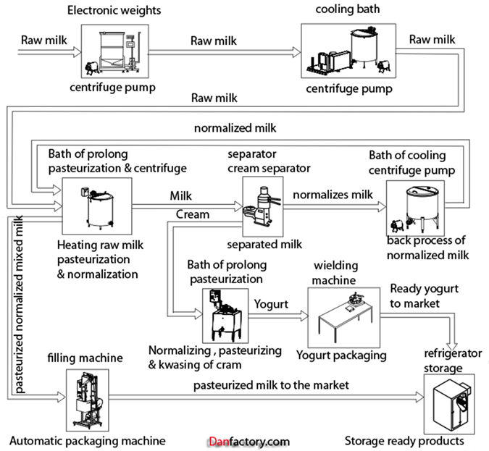
Figure 1. Process Chart

You have two options to continue performing this part:
1. Find a problem related with industrial engineering and make a proper problem definition by identifying the scope, reasons and the effects of the problem.
2. Find a process which, in your opinion, needs improvement. Explain why the process needs improvement by specifying the current and potential effects of suboptimal performance.

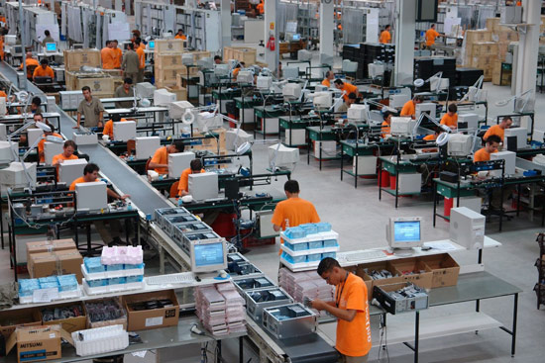
Figure 2. Production Line

Do not just write that you have made an analysis, provide proof of your work, and justify your data, if collected. Explain the methods you used in your analysis and indicate your data collection techniques.

Table 1. Time Study Results
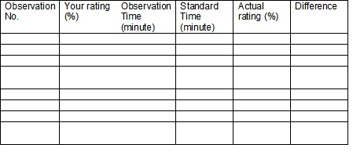

Associate your work with at least 2 of the courses you took (coded EMÜ).

For each one of the courses that you are associating your work with, you should create a subsection on your report. In each subsection you should clearly indicate:
- With which course and which part(s) of this course you are associating your work.
- The theoretical aspects of the course that you observed in your actual work.
- How similar the work that you actually performed in your internship was to what you covered in the course.
- How different the work that you actually performed in your internship was from what you covered in the course.

- CONCLUSIONS

Give an interpretation of your results. What do they mean? What are the shortcomings of your work? Did you have to make some assumptions which might alter the real behavior of the system you are analyzing? What kind of conclusions did you reach?
Share your observations about the interactions of industrial engineers (you and/or company employees) with other employees/managers from other disciplines (i.e. computer engineering, psychology, management, economics, etc.). How have people from other disciplines affected your work (or the work of other industrial engineers in the company), and how have you affected the work of others?
What are your contributions to the company? Did you participate in making an improvement? What did you gain from this internship?

Your conclusions should not exceed 3 pages.

- REFERENCES

References should be identified in the text using the number given in your references list. Your references list should be sorted in alphabetical order using the last names of the first author. Please note that books, papers, thesis etc. have different formats. While writing the references please follow the guidelines below.

Periodicals
Name of the periodicals should be written fully in italic. After the name of the periodical, volume and page numbers should be followed by the publication year.

Periodicals: (printed)
[1] Aksoy, B., Ercanoğlu, M., Landslide identification and classification by object-based image analysis and fuzzy logic: An example from the Azdavay region, Computers and Geosciences, 38, 87-98, 2012.

Web based periodicals:
[5] Kadılar, C., Çıngı, H., New ratio estimators using correlation coefficient, Interstat, 2006, http://interstat.statjournals.net/YEAR/2006/articles/0603004.pdf

Web page:
http: //www.regweb.psut.edu.jo/Base/SemTable.assbx, cited on 20 January 2014.

Books:
Book names should be written in italic.
[5] Nahmias, S. Production & Operations Analysis, 6th Ed., McGraw Hill-Irwin, 2009.

Conference proceedings:
[12] Günay, G., Arıkan, A., Ekmekçi, M., Quantitative determination of bank storage in reservoirs constructed in karst areas: Case study of Oymapınar Dam, Turkey: Proceedings of the International Symposium on Karst Water Resources Research, 7-19 July, 1985, Ankara, Antalya-Turkey: (eds:G. Günay and A. I. Johnson), IAHS Publ. no. 161, 321-332, 1985.
- APPENDIX

Add all supplementary material that is not directly related to your discussions to this part by naming them properly.

